
PYTHON PROGRAMMING LAB FILE

Name: Krishna Som
Sap ID: 590025475
Batch: 34
Teacher: Sugandha Sharma

Exception Handling:
Objective 4: Input two values from user where the first line contains N, the number of test cases. The next N lines contain the space separated values of a and b. Perform integer division and print a/b. Handle exception in case of ZeroDivisionError or ValueError.
Sample input
1 0
2 $
3 1
Sample Output:
Error Code: integer division or modulo by zero
Error Code: invalid literal for int() with base 10: '$' 3
Code:
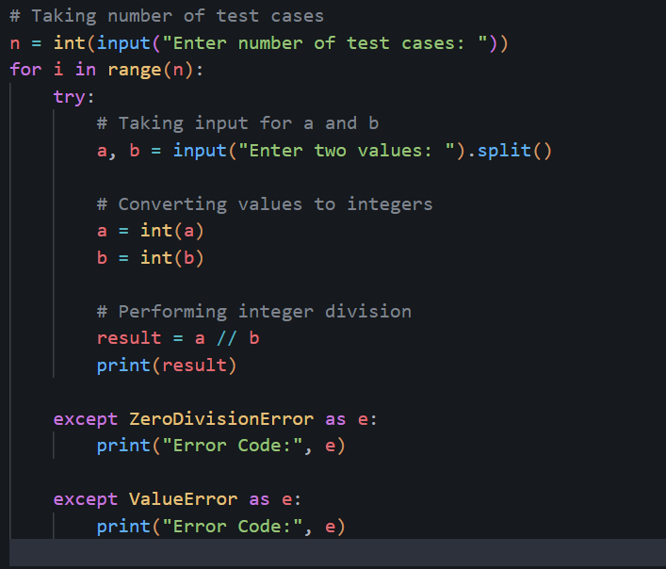
Output:
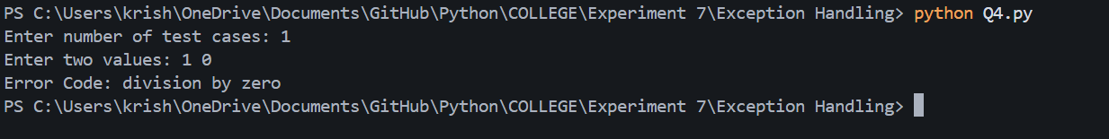

Objective 5: Create multiple suitable exceptions for a file handling program.

Code:
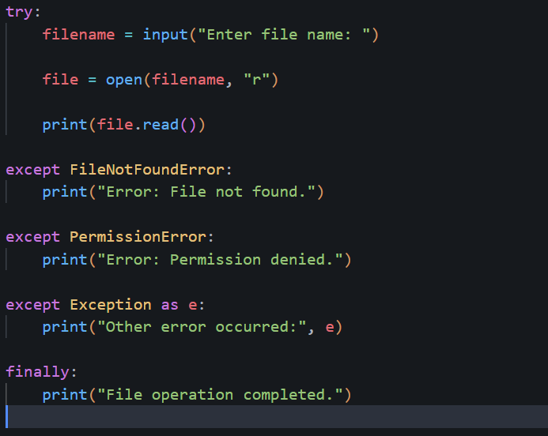

Output;
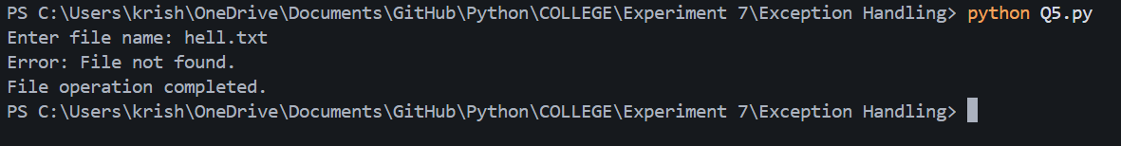

Objective 6: Write a program to create a counter to show that how many times the program is executed.

Code:
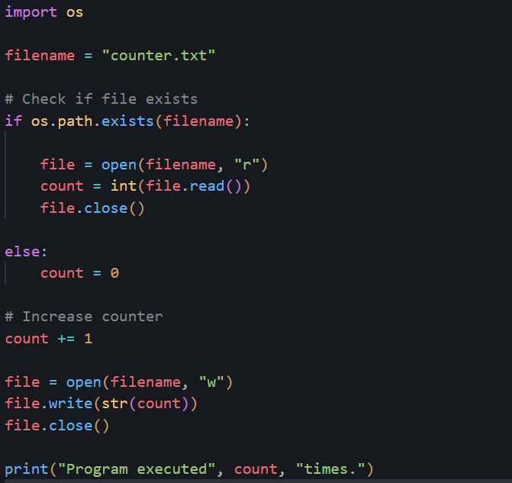

Output:

